**Leetcode Soln**

1. <https://leetcode.com/problems/running-sum-of-1d-array/>

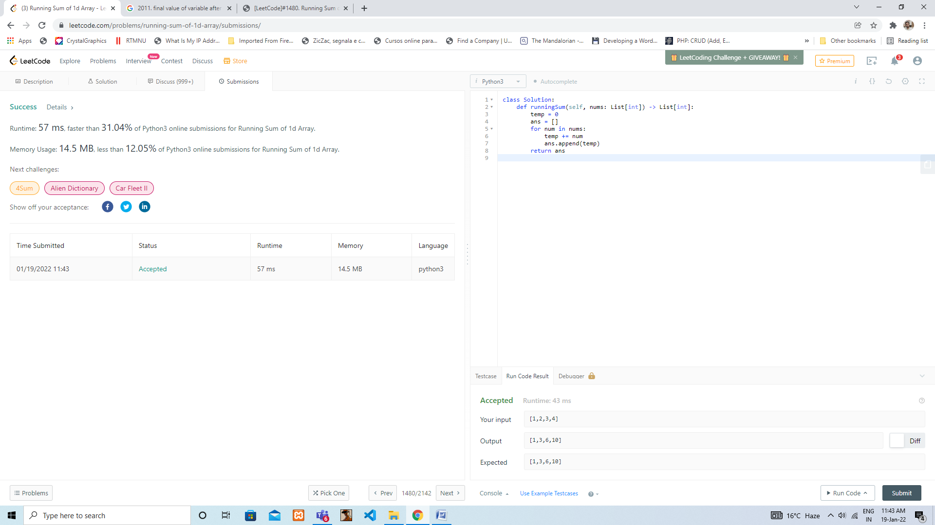

1. <https://leetcode.com/problems/final-value-of-variable-after-performing-operations/>

